Nachname = last name, Vorname = first name
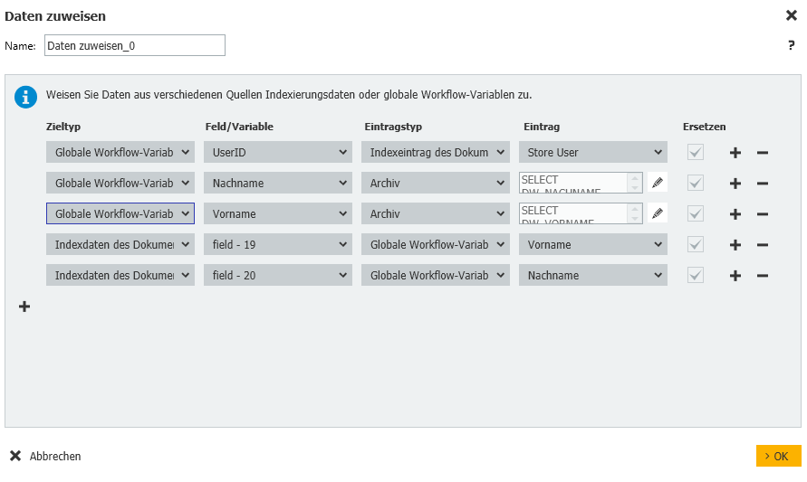
First, we need 3 global variables (UserID, last name, first name). In the next step we fill the global variable UserID with the index field of the document “Store User”.
Then we fill the global variables first and last name with entries from the auxiliary file cabinet as shown below (Here we must match the index field DW_UserID from the auxiliary file cabinet with the global variable, which we have just filled with the Store User):
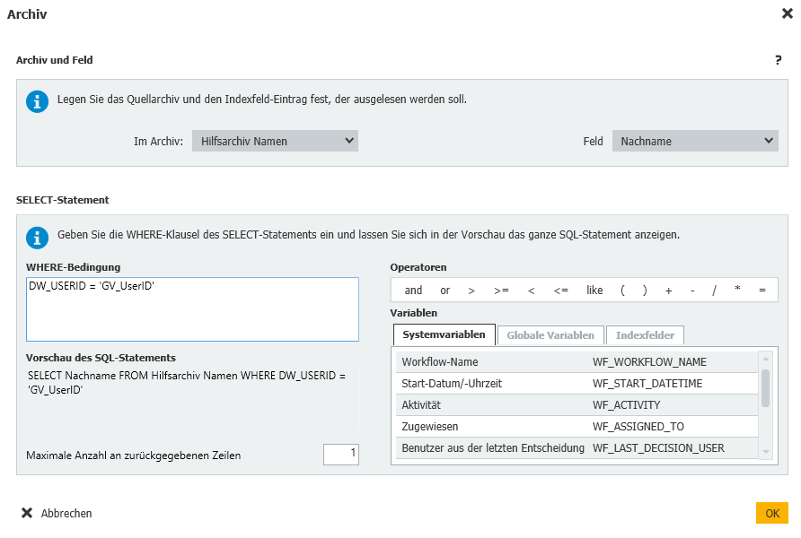
And in the last step we can then fill in some index fields of the document with the global variables first and last name which we have just filled.

