Hello,
I would like to use the Import folder with .xml file as metadata:
I set an easy test environnement.
The cabinet “MetaTest” get the following indexes:
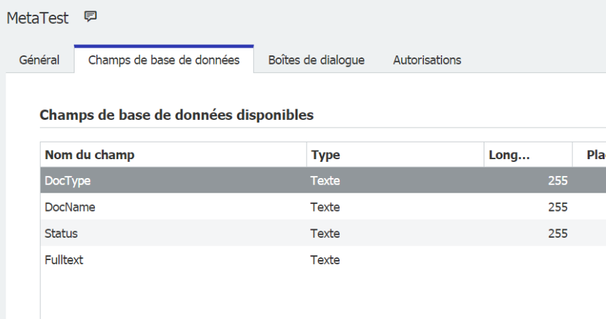
I set the document process:
To process .xml and link to the cabinet “MetaTest”
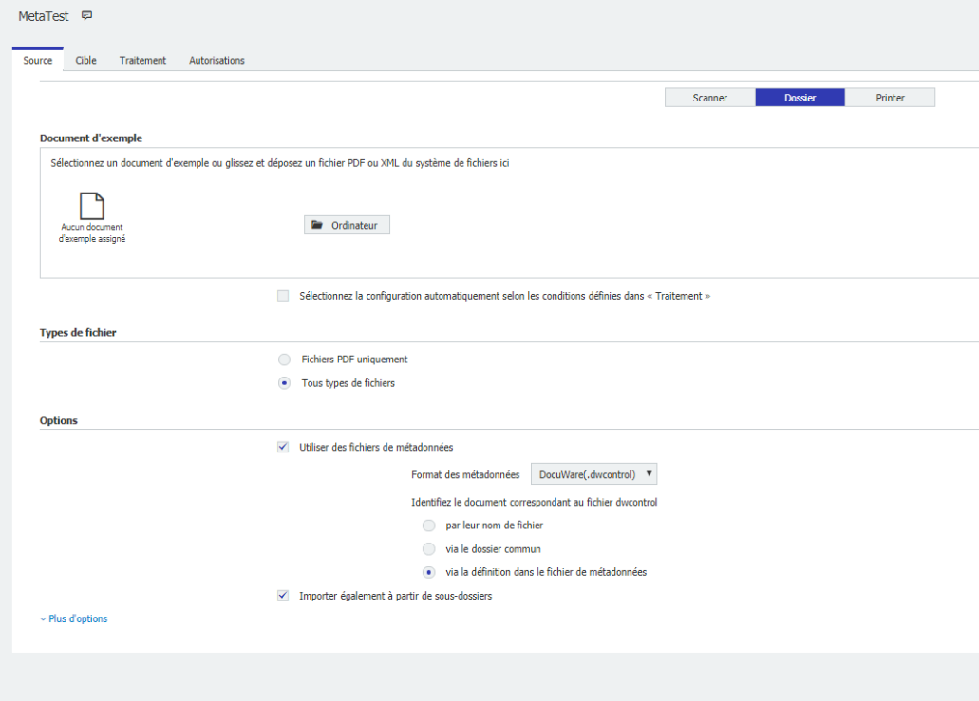
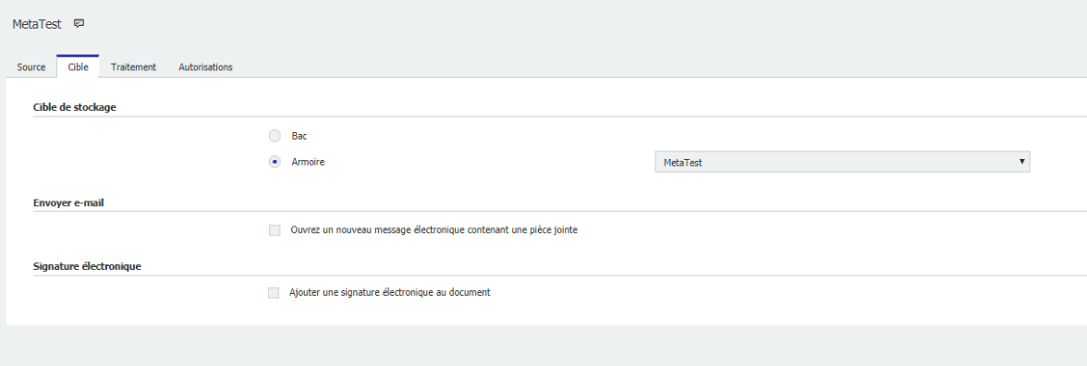

Create the Docuware Import Jobs Folder:
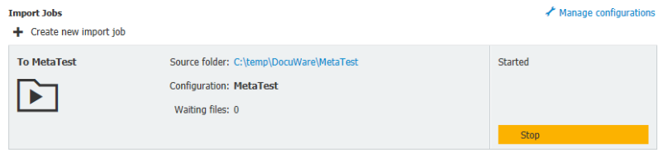

I use the following xml exemple:
<ControlStatements xmlns="http://dev.docuware.com/Jobs/Control" xmlns:xsi="http://www.w3.org/2001/XMLSchema-instance">
<Document>
<InsertFile path="C:\DWPROCESSING\Metaindex_XML_and_Image\Metadata\Data\Files\100011.tif" />
<InsertFile path="C:\DWPROCESSING\Metaindex_XML_and_Image\Metadata\Data\Files\100021.tif" />
<InsertFile path="C:\DWPROCESSING\Metaindex_XML_and_Image\Metadata\Data\Files\100031.doc" />
</Document>
<Page>
<FileCabinet name="PE Documents"/>
<Field dbName="COMPANY" type="Text" value="Peters Engineering"/>
<Field dbName="DEPARTMENT" type="Text" value="Construction"/>
<Field dbName="SUBJECT" type="Text" value="Area determination"/>
<Field dbName="DOC__TYPE" type="Text" value="invoice"/>
<Field dbName="PROJECT" type="Text" value="DE2004007"/>
<Field dbName="DOC__DATE" type="Date" value="2010-04-03" culture="en-US" format="yyyy-MM-dd"/>
</Page>
</ControlStatements>

I modify it like this:
<ControlStatements xmlns="http://dev.docuware.com/Jobs/Control" xmlns:xsi="http://www.w3.org/2001/XMLSchema-instance">
<Page>
<FileCabinet name="MetaTest"/>
<Field dbName="DocType" type="Text" value=" Info"/>
<Field dbName="DocName" type="Text" value="Guide for QR invoices"/>
<Field dbName="Status" type="Text" value="New"/>
</Page>
</ControlStatements>

The fields should be fill-in via AutoStore when I find the way to import .xml.

I copy the two files in the Import folder, but nothing is processed:
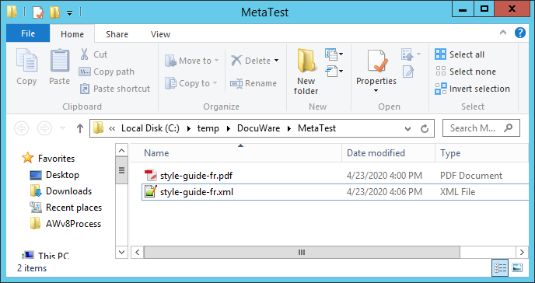

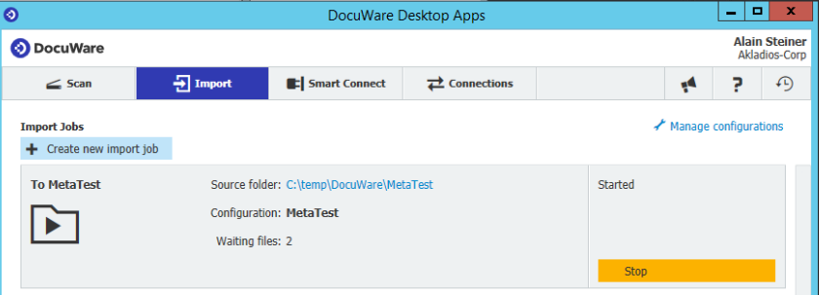
=>
I try various .XML without success:
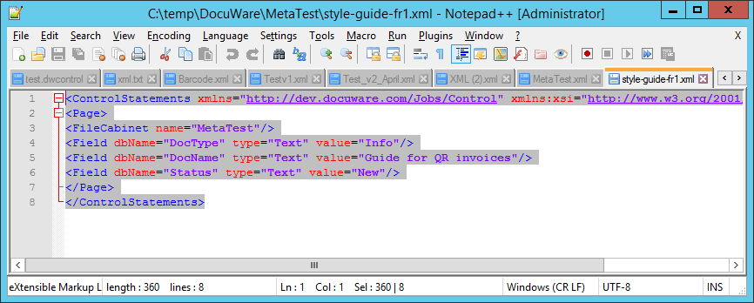

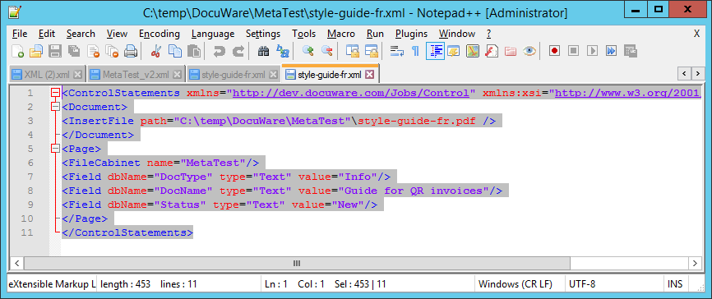
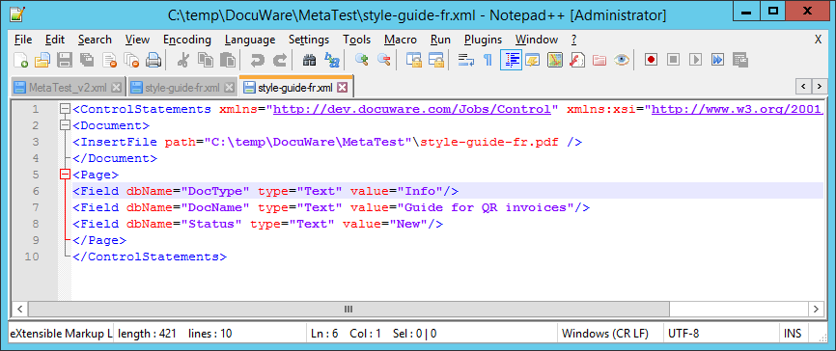
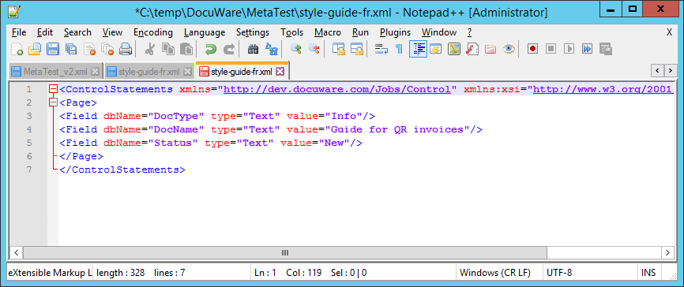

Thanks for you help
Regards
Alain

