View Only
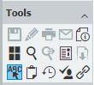

View, Download, Print, Email
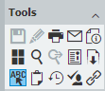

When someone right click a result line and tries to download, print, or email a View Only document a new web tab will open and display this error.
