Docusign Workflow:
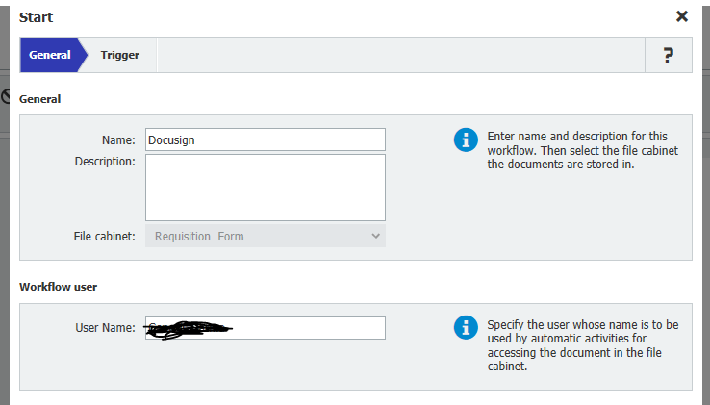
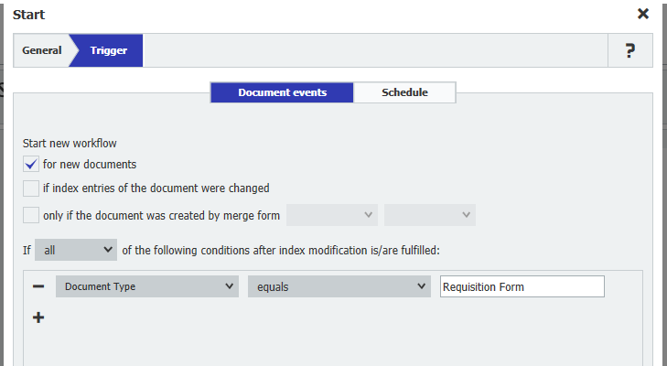

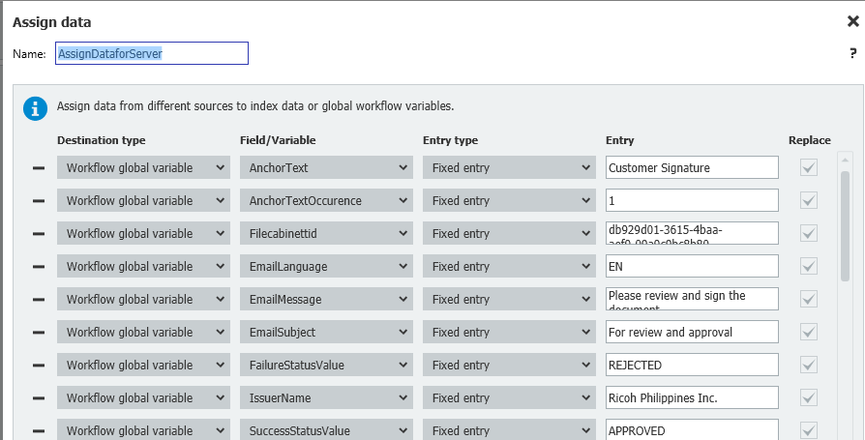
2.

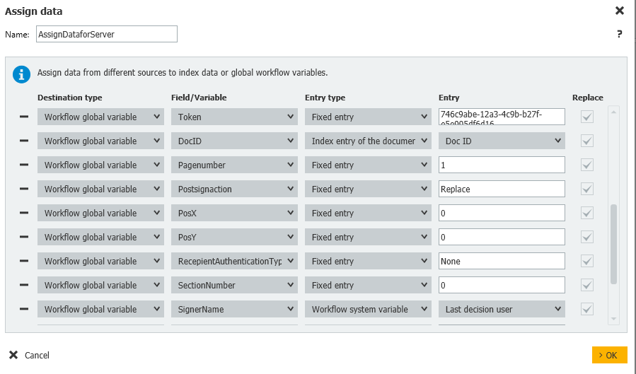

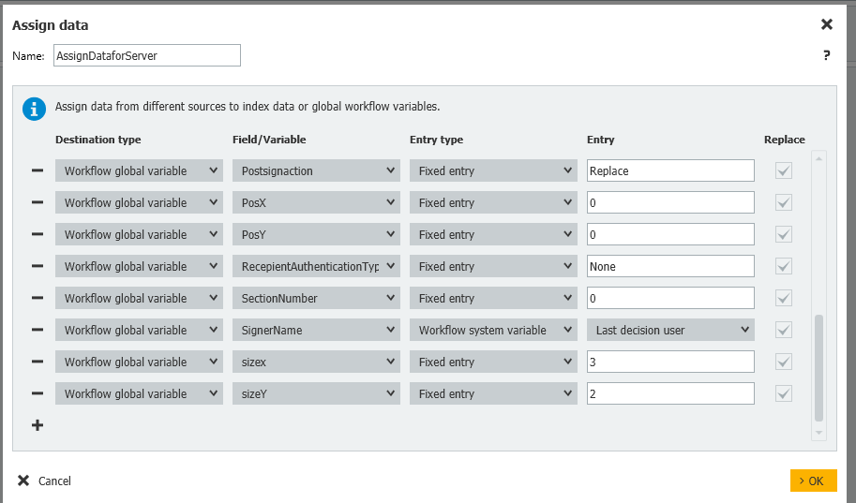

Some of the fields in the KB procedure is not included here because it says optional.

Registering New Organization from Docusign:

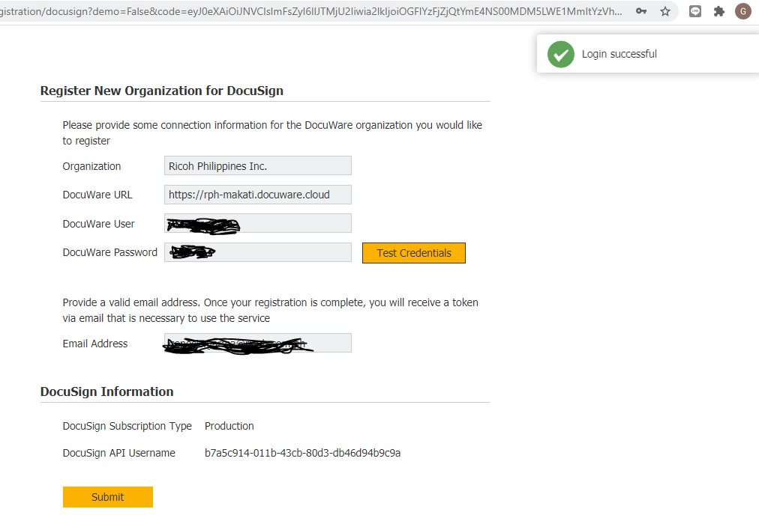

After I submit this, I receive an email from Docuwre and given me the Signature Service Token.

Then I configure the Web Services Configuration:

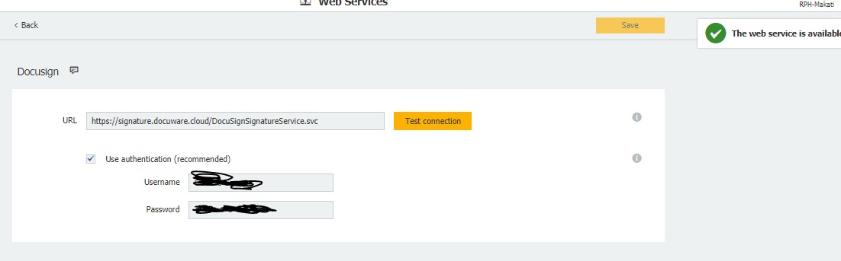

Here’s the screenshot for Web Services Configurator in docuware.
I just want to ask here, if what authentication I need to input, Is it my login credential in Docuware account or in Docusign? I tried both and test the connection and both is okay.

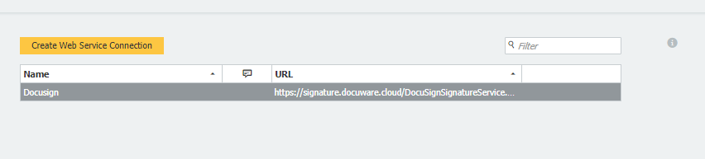

Web Service Configuration in Workflow:

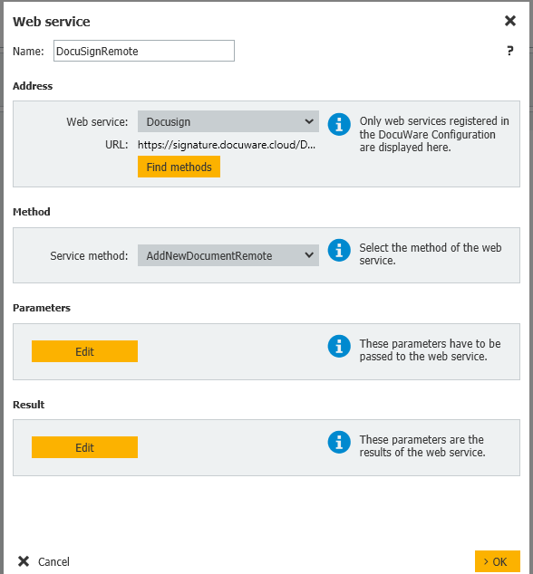

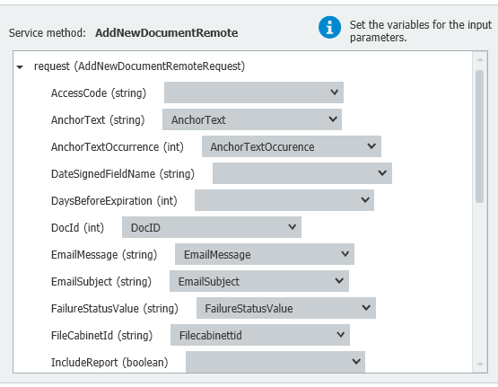
Parameters:

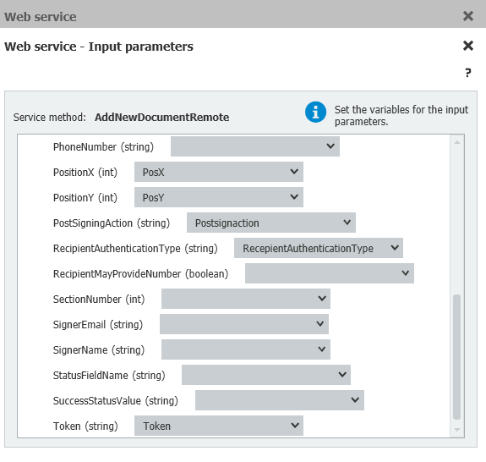

Some of the fields there is blank. Because I don’t know what to input and configure in the workflow global variable.

Even here in result parameters:

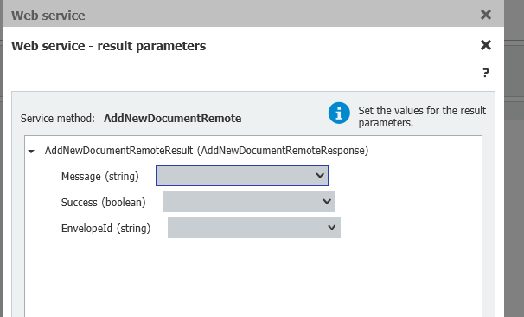

I don’t know what to choose here.
On KB screenshot,

ResultMessage (String)
Success (Boolean)
EnvelopeID (String)

