Convert String to Date
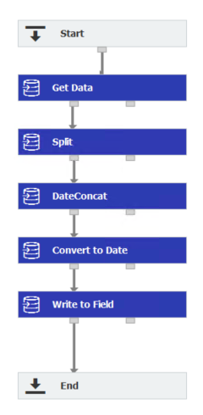
Set Variables
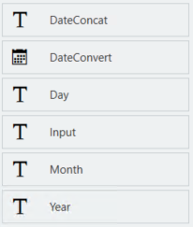
Assign string to variable
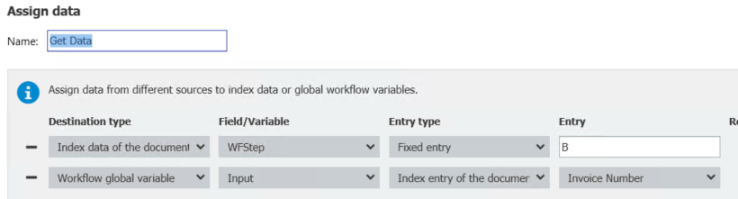
Split out parts of date
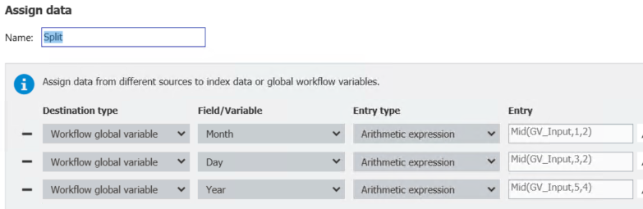
Mid(GV_Input,1,2)
Mid(GV_Input,3,2)
Mid(GV_Input,5,4)

Concatenate into a proper date string
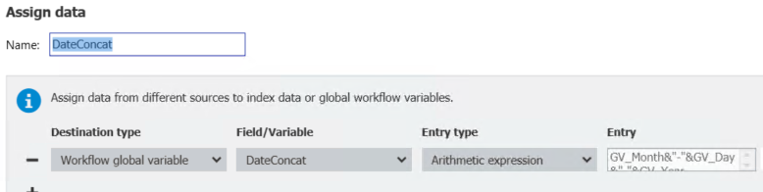
GV_Month&"-"&GV_Day&"-"&GV_Year
Convert the proper string to a date
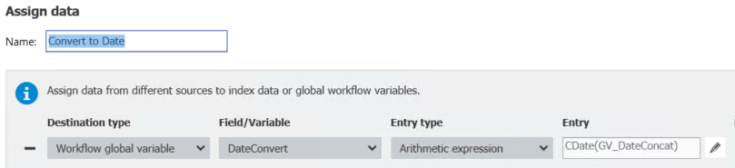
CDate(GV_DateConcat)

Write this value to the index field
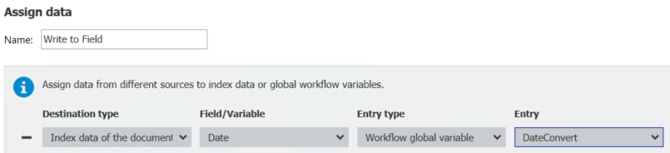

Results in Variables;
