**In Document Viewer Pane:**

View Only

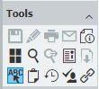

View, Download, Print, Email

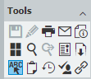

**From Result List:**

When someone right clicks a result line from the result list and tries to download, print, or email, for View Only document, the selectable item is there and when chosen, a new web tab will open and display this error.

